### A PROJECT REPORT

**on**

# “Intelligent Valve Control Mechanism For Irrigation In Precision Agriculture.”

**Submitted by**

**Sejal Hanmante (72158008E) Rameshwari Kadrame (72157921D)**

**Mohit Badgujar (72157866H)**

**Prathamesh Sharma (72158011E)**

**Under the guidance of Dr. M. P. Hajare**

***in partial fulfillment for the award of the degree of***

### Bachelor of Engineering

in

**ELECTRONICS AND TELECOMMUNICATION ENGINEERING**

**SAVITRIBAI PHULE PUNE UNIVERSITY**

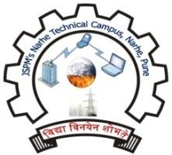

### DEPARTMENT OF

**ELECTRONICS AND TELECOMMUNICATION ENGINEERING JSPM NARHE TECHNICAL CAMPUS, PUNE - 411041**

##### Academic Year 2023-2024

 

|  |
| --- |
| **Jayawant Shikshan Prasark Mandal’s** |
| **JSPM NARHE TE**C**HNICAL CAMPUS,**  **PUNE - 411041** |

### DEPARTMENT OF

**ELECTRONICS AND TELECOMMUNICATION ENGINEERING**

## CERTIFICATE

This is to certify that a Project Report on

**“Intelligent Valve Control Mechanism For Irrigation In Precision Agriculture.”**

By

**Sejal Hanmante (72158008E) Rameshwari Kadrame (72157921D)**

**Mohit Badgujar (72157866H)**

**Prathamesh Sharma (72158011E)**

*is a bonafide work carried out by them during the academic year 2023-2024 in partial fulfillment of the requirement for the award of Degree of Bachelor of Engineering in Electronics and Telecommunication Engineering under Savitribai Phule Pune University, Pune.*

Dr. M. P. Hajare Dr. K. P. Wagh

Project Guide Project Co-Ordinator

Dr. A. S. Patil Dr. M. M. Sardeshmukh Head of Department Director

External Examiner

Date: / / 2024 Place: Pune

## ACKNOWLEDGEMENT

We would like to convey our deepest gratitude to our respected project guide, **Dr. M. P. Hajare,** for her help and guidance throughout the duration of our work.

We would like to convey our hearty thanks to all of our staff members and most importantly our Project Co-ordinator, **Dr. K. P. Wagh** and Head of Department, **Dr. A. S. Patil** and Director **Dr. M. M. Sardeshmukh** for all kind of coordination related to the project and allowing us to use the college resources required for the project.

We would like to thank our parents for standing behind us all the time and we thank our friends for their advice, guidance and help.

**Sejal Hanmante**

**Rameshwari Kadrame**

**Mohit Badgujar**

**Prathamesh Sharma**

## ABSTRACT

The project "Intelligent Valve Control Mechanism for Irrigation in Precision Agriculture" proposes an innovative approach to address the challenges of water management in agriculture using IoT and machine learning techniques. The project aims to maximize crop yield by ensuring optimal irrigation levels while minimizing water wastage.

The hardware components of the system include moisture sensors, humidity sensors, rain sensors, and a flow sensor for the intelligent valve. These sensors are deployed in the field to collect real-time data on soil moisture, weather conditions, and water flow. The data collected by these sensors is used as input for the machine learning model, which predicts the water requirements of the crops based on the current conditions.

The machine learning model considers various factors such as soil moisture levels, humidity, and rainfall forecasts to determine the precise amount of water needed for irrigation. This information is then used to control the intelligent valve, which regulates the flow of water from the water tank to the fields. The valve opens and closes automatically based on the predictions made by the machine learning model, ensuring that the crops receive the right amount of water at the right time.

One of the key advantages of the proposed system is its ability to prevent under-watering and over-watering of crops. By continuously monitoring soil moisture levels and weather conditions, the system can adjust irrigation levels dynamically, ensuring that the crops receive optimal moisture levels throughout their growth cycle. This not only maximizes crop yield but also conserves water resources by avoiding unnecessary irrigation.

In addition to its water-saving benefits, the proposed system also offers a high degree of intelligence, reducing the need for manual intervention in the irrigation process. Farmers can monitor and control the irrigation system remotely using a mobile application, allowing them to manage their crops more efficiently and effectively.

Overall, the "Intelligent Valve Control Mechanism for Irrigation in Precision Agriculture" project represents a significant advancement in the field of agriculture technology. By combining IoT and machine learning, the project offers a sustainable solution to the challenges of water management in agriculture, ultimately contributing to the goal of achieving food security and environmental sustainability.

##### CONTENTS

|  |  |  |
| --- | --- | --- |
| **SR.NO** | **TITLE** | **PAGE NO** |
|  | **Acknowledgement** | **I** |
|  | **Abstract** | **II** |
|  | **Contents** | **III** |
|  | **List of Figure** | **V** |
|  | **List of Abbreviation** | **VI** |
| **1** | **Introduction** |  |
| 1.1 | Introduction to system | 1 |
| 1.2 | Relevance | 2 |
| 1.3 | Problem Statement | 2 |
| 1.4 | Objective of Project | 2 |
| 1.5 | Organization of Report | 3 |
| **2** | **Literature Survey** | 4 |
| **3** | **Methodology and System Design** | 6 |
| 3.1 | Block Diagram | 7 |
| 3.2 | Description | 7 |
| 3.3 | Circuit Diagram | 8 |
| 3.4 | Algorithm | 8 |
| 3.5 | Hardware Specifications | 10 |
|  | III |  |

|  |  |  |
| --- | --- | --- |
| 3.6 | Proteus Simulation | 23 |
| **4** | **System Implementation** |  |
| 4.1 | Implementation | 24 |
| 4.2 | Random Forest Algorithm | 29 |
| **5** | **Results** |  |
| 5.1 | Testing Water Prediction Results | 29 |
| 5.2 | Mobile Application Interface | 30 |
| **6** | **Advantages, Limitations, Applications and Future Scope** |  |
| 6.1 | Advantages | 33 |
| 6.2 | Limitations | 33 |
| 6.3 | Applications | 33 |
| 6.4 | Future Scope | 34 |
| **7** | **Conclusion** | 36 |
|  | **Project Timeline** | 37 |
|  | **References** | 33 |
|  |  |  |
|  | IV |  |

|  |  |  |
| --- | --- | --- |
| **FIGURE NO.** | **NAME OF FIGURE** | **PAGE NO.** |
| 3.1 | Block Diagram of Proposed System | 7 |
| 3.2 | Circuit Diagram | 8 |
| 3.3 | Decision making framework for management | 10 |
| 3.4 | Raspberry Pi 4B Model | 11 |
| 3.5 | Pinout and Functions | 12 |
| 3.6 | DHT11 | 15 |
| 3.7 | Rain Drop Detection Sensor | 16 |
| 3.8 | Soil Moisture Sensor | 18 |
| 3.9 | Solenoid Water Valve | 20 |
| 3.10 | Proteus Simulation | 22 |
| 4.1 | Hardware Design | 23 |
| 4.2 | Data Visualization | 24 |
| 4.3 | Welcome Page | 26 |
| 5.1 | Testing Water Prediction | 28 |
| 5.2 | Plot of Water Requirement | 28 |
| 5.3 | Home page | 29 |
| 5.4 | Login Page | 29 |
| 5.5 | Sensor Records Page | 30 |
| 5.6 | System Implementation | 31 |
|  | V |  |

**CHAPTER 1 INTRODUCTION**

##### Introduction of system

Efficient water management is essential for sustainable agriculture. However, traditional irrigation systems often lack the precision required to deliver water tailored to the actual needs of crops, leading to water wastage, suboptimal plant growth, and environmental degradation. This problem is particularly pronounced in piped and micro irrigation networks, where manual control methods fail to adapt dynamically to varying soil moisture conditions within the root zone of crops.

To address this challenge, we propose to develop an AI-powered intelligent irrigation system that can regulate the release of water based on real-time soil moisture availability. The system will utilize a variety of sensors and communication technologies to collect and transmit data to a central AI system. The AI system will then use this data to predict crop water requirements and make decisions about water release timing and quantities. The system will be integrated with existing piped and micro irrigation networks to deliver water to crops in a precise and efficient manner.

For comparable, consistent and functional results, those working in fabrication room, production line and clean rooms require stable, controllable atmospheric conditions. The temperature and humidity are particulars sense to influence the viscosity and properties of materials, as well performed of chemical reactions. Humidity is a primary initiator and booster for devastating effects on electronics and a constant threat to efficient production and product qualities. The necessity of this system is to minimize manpower on controlling air temperature and humidity of surroundings in industries as the effect of decrease in the devastating effects on electronics components.

##### Relevance

The system can provide crops with the precise amount of water they need at the right time, leading to increased yields. The system can help farmers to reduce water consumption by avoiding overwatering and by ensuring that water is only applied when needed. The system can help to protect the environment by reducing water pollution and by conserving groundwater resources. The system can automate the irrigation process, saving farmers time and labor costs. The system can help farmers to produce higher quality crops by ensuring that they receive the optimal amount of water. In addition to these specific results, the AI-powered intelligent irrigation system can also have a number of other benefits. The system can help to reduce the risk of crop failure by ensuring that crops are not overwatered or underwatered.

##### Problem Statement

Intelligent regulation of valves for release of water based upon soil moisture availability in the root zone of the crop, using artificial intelligence, in a piped and micro irrigation network of irrigation system.

##### Objective of Project

The objective of this project is to develop an AI-powered intelligent irrigation system that can regulate the release of water based on real-time soil moisture availability in the root zone of the crop.

##### Organization of Report:

Chapter 1 “Introduction” contains a brief explanation of root of the project following the problem statement where whole process starting with initial phase to execution phase is expected to be delivered.

Chapter 2 “Literature Survey” consists of information researched from previous study papers and authorized articles which displays the summery of the motive with various references of books, articles and other available resources.

Chapter 3 “Methodology and System Design” provides all the design aspects related with the system. It contains basic block diagram for designed system as well as brief information about hardware and software.

Chapter 4 “System Implementation” contains a structured procedure and flow of the actual idea explaining the working principle of every particular component.

Chapter 5 “Results” contains various outputs taken after performing the process.

Chapter 6“Advantages, Limitations, Applications & Future Scope” provides with advantages, limitations, applications and future scope of the project.

Chapter 7 “Conclusion” submits the results of execution phase where the aim of the project is compared to its highest accuracy throughout the process with all the possibilities of opportunities to its applications.

##### CHAPTER 2 LITERATURE SURVEY

Precision agriculture is an advanced farming approach that aims to optimize resource utilization, increase crop yields, and reduce environmental impact. Irrigation is a critical component of precision agriculture, and efficient control mechanisms for irrigation systems are essential. Intelligent valve control systems are integral to precision agriculture as they allow for precise control of water distribution. They help address issues such as over-irrigation, water wastage, and uneven water distribution, ultimately leading to improved crop yields and resource efficiency. Precision agriculture relies heavily on sensor technologies. Various sensors, such as soil moisture sensors, weather stations, and crop health sensors, provide crucial data for making informed decisions regarding irrigation. Integrating sensor data with intelligent valve control mechanisms allows for data-driven irrigation decisions. Artificial intelligence (AI) and machine learning (ML) techniques have the potential to enhance intelligent valve control in irrigation. AI can analyze sensor data and weather forecasts to make predictions and automate irrigation decisions. ML models can optimize irrigation schedules based on historical data and crop-specific requirements.

**2.1 Introduction**

Precision agriculture is a farming management concept that uses IoT and AI technologies to optimize the use of resources and maximize crop yield. One of the critical aspects of precision agriculture is efficient irrigation management, which involves providing the right amount of water to crops at the right time. Traditional irrigation methods often lead to under-watering or over-watering, resulting in reduced crop yields and wastage of water resources. To address these challenges, researchers have been exploring the use of intelligent irrigation systems that can automatically control the irrigation process based on real-time data and predictive models.

**2.2 IoT and Agriculture**

The Internet of Things (IoT) has emerged as a promising technology for improving various aspects of agriculture, including irrigation management. IoT devices such as sensors and actuators can be deployed in the field to collect data on soil moisture, weather conditions, and crop health. These devices can communicate with each other and with a central control system to enable real-time monitoring and control of irrigation operations.

**2.3 Machine Learning in Agriculture**

Machine learning (ML) algorithms have been widely used in agriculture to analyze data and make predictions related to crop growth, pest infestation, and irrigation requirements. In the context of irrigation management, ML models can be trained on historical data to predict the water requirements of crops based on factors such as soil moisture, weather conditions, and crop type.

**2.4 Intelligent Valve Control Mechanism**

The proposed intelligent valve control mechanism for irrigation in precision agriculture combines IoT and machine learning technologies to optimize the irrigation process. The system consists of various hardware components, including moisture sensors, humidity sensors, rain sensors, and flow sensors, which are used to collect data on soil moisture, weather humidity, rainfall, and water flow rate.

**2.5 Existing Work**

Several research studies have explored the use of IoT and ML in irrigation management. For example, a study by Li et al. (2018) proposed an intelligent irrigation system based on IoT and cloud computing technologies. The system used soil moisture sensors to collect data and ML algorithms to predict irrigation requirements.

**2.6 Proposed Model**

The proposed model for intelligent valve control in irrigation uses a machine learning model to predict the water requirements of crops based on real-time data from sensors. The model takes into account factors such as soil moisture, weather humidity, and rainfall to determine the optimal irrigation schedule. The intelligent valve is then used to control the flow of water from the water tank to the field based on the predictions made by the ML model.

**2.7 Conclusion**

In conclusion, the proposed intelligent valve control mechanism for irrigation in precision agriculture represents a significant advancement in the field of agriculture technology. By integrating IoT and machine learning technologies, the system can optimize irrigation management, reduce water wastage, and maximize crop yields. Further research is needed to evaluate the performance of the system in real-world agricultural settings and to explore opportunities for scalability and cost-effectiveness.

Examining real-world case studies and implementations of intelligent valve control mechanisms in precision agriculture provides insights into their practical application. These studies can showcase the benefits, challenges, and results achieved in various agricultural settings.

##### CHAPTER 3 METHODOLGY AND SYSTEM DESIGN

* 1. **Block Diagram**

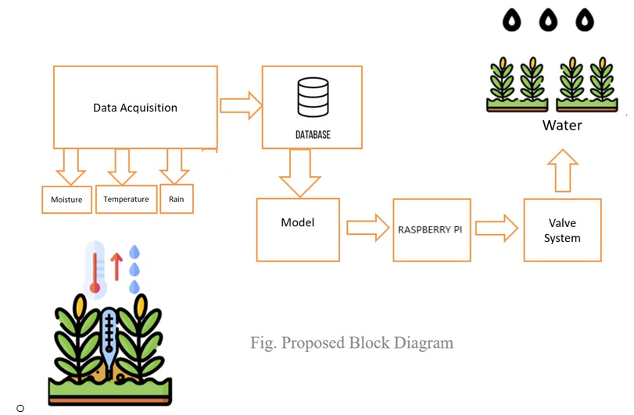

##### Fig. 3.1 Block Diagram of Proposed System

* 1. **Description**

This block diagram shows how different components of the intelligent valve control mechanism are connected together and the co-ordination to give accurate outputs as it will be the amount of water decided on the basis of decision took by ML model which is provided inputs by sensors. Finally, a data representation of sensors and actuators is displayed in the cloud layer in the form of a user interface dashboard. The suggested system is notable for its ability to assist farmers by providing management using an IoT-based precision farming framework.

##### Circuit Diagram

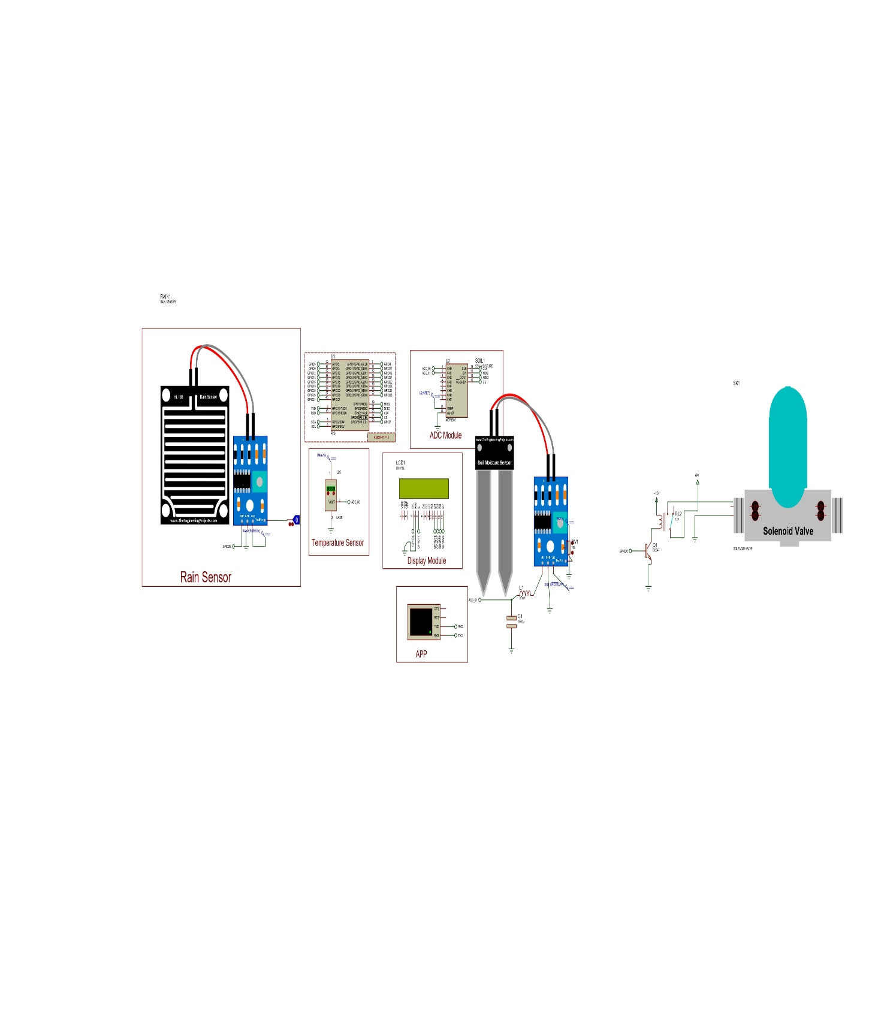

**Fig. 3.2 Circuit Diagram**

##### Algorithm

* + 1. **Sensor Layer**

In this project, the sensors are used to monitor the factors of the environment included dht11 sensor for temperature and humidity, soil moisture sensor and rain sensor. In addition, actuators were chosen and deployed to control equipment like valves according to relaying parameters.

##### Edge Layer

Sensors, referred to as nodes or edges, were put in the field at various locations and connected to a low-power microcontroller designed for the IoT. We used Raspberry pi 4B in our project, which could gather and predict data from sensors before transferring them to the edge layer’s. Sensors are checked against an expected value to collect data in analogue or digital form according to the requirements. Data was collected for various climate variables, both healthy and unhealthy, to better comprehend all possible environmental situations.

##### Fog Layer

This layer’s primary responsibility was to deal with decision making, to control the activity of the edge layer, and to communicate related data to the cloud layer for use of farmers. A machine learning algorithm (Random Forest) created the decision-making system via many processing phases, starting from the data generated by edge-layer sensors [3]:

• Data gathering by IoT devices, particularly sensors, which could collect data in small batches (temperature, humidity and soil moisture).

• Data collection and aggregation in a target database.

• Computing: During this phase, calculations were performed on the classified data (e.g., the amount of water required to crop).

• Making decisions based on predictions and visualizing data in the form of reports or dashboard.

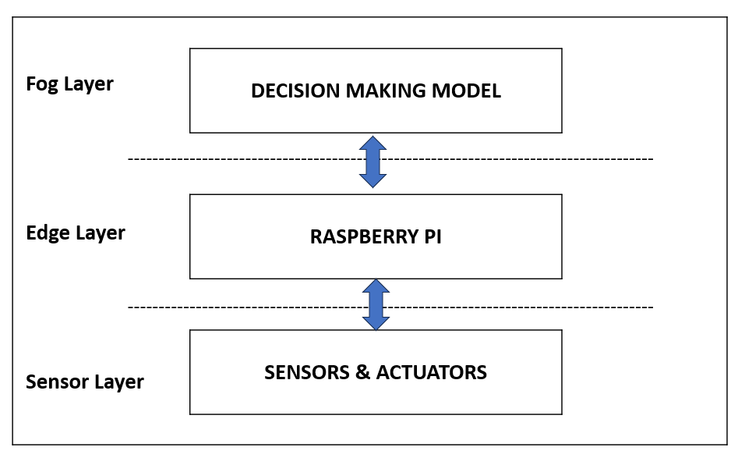

##### Figure 3.3 Decision making framework for management

* 1. **Hardware Specification**

Hardware specifications explains structure and working principles of the hardware components. It refers to the detailed technical information and characteristics of hardware components in this project.

##### Raspberry pi 4B

Raspberry Pi 4 Model B features a high-performance 64-bit quad-core processor, dual-display support at resolutions up to 4K via a pair of micro-HDMI ports, hardware video decodes at up to 4Kp60, up to 8GB of RAM, dual-band 2.4/5.0 GHz wireless LAN, Bluetooth 5.0, Gigabit Ethernet, USB 3.0, and PoE capability (via a separate PoE HAT add-on). For the end user, Raspberry Pi 4 Model B provides desktop performance

comparable to entry-level x86 PC systems. This product retains backwards compatibility with the prior-generation Raspberry Pi 3 Model B+ and has similar power consumption, while offering substantial increases in processor speed, multimedia performance, memory, and connectivity.

The dual-band wireless LAN and Bluetooth have modular compliance certification, allowing the board to be designed into end products with significantly reduced compliance testing, improving both cost and time to market.

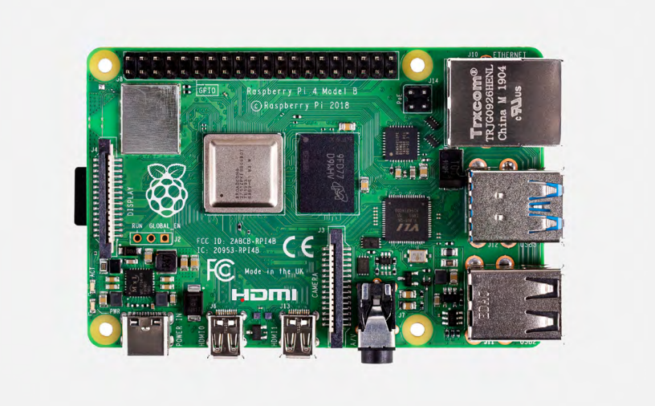

**Figure 3.4 Raspberry pi 4B model**

**Specification:**

1.Processor: Broadcom BCM2711, quad-core Cortex-A72 (ARM v8) 64-bit SoC @ 1.5GHz

2.Memory: 1GB, 2GB, 4GB or 8GB LPDDR4 (depending on model) with on-die ECC

3.Connectivity: 2.4 GHz and 5.0 GHz IEEE 802.11b/g/n/ac wireless LAN,

Bluetooth 5.0, BLE

Gigabit Ethernet

2× USB 3.0 ports

2× USB 2.0 ports.

4.GPIO: Standard 40-pin GPIO header

(fully backwards-compatible with previous boards)

5.Video & sound: 2 × micro-HDMI ports (up to 4Kp60 supported)

2-lane MIPI DSI display port

2-lane MIPI CSI camera port

4-pole stereo audio and composite video port

6.Multimedia: H.265 (4Kp60 decode);

H.264 (1080p60 decode, 1080p30 encode);

OpenGL ES, 3.0 graphics

7.SD card support: Micro SD card slot for loading operating system and data storage

8.Input power:5V DC via USB-C connector (minimum 3A1) 5V DC via GPIO header (minimum 3A1) Power over Ethernet (PoE)–enabled (requires separate PoE HAT)

9.Environment: Operating temperature 0–50ºC Production lifetime: Raspberry Pi 4 Model B will remain in production until at least January 2031.

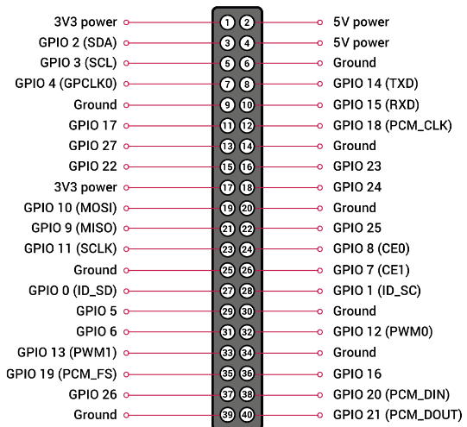

**Figure 3.5 Pin out and function diagram**

**PIN SPECIFICATIONS:**

* Ground pins :- The ground is very useful for making a common reference between all components in your circuit. Always remember to connect all components to the ground.
* Power pins :- You can find 2 pins bringing 3.3V and 2 pins bringing 5V.Those pins can be used to power components such as sensors or small actuators.
* Reserved pins :- The pins 27 and 28 are reserved pins. They are usually used for I2C communication with an EEPROM.
* Raspberry Pi 4 GPIOs

GPIO means General Purpose Input/Output. Basically, that’s one pin you can use to write data to external components (output), or read data from external components (input).

If you embed your Raspberry Pi board with some hardware components, the GPIO header will become quite useful.

* GPIOs are digital pins: The Raspberry Pi 4 GPIOs are quite similar to what we call “digital pins” on an Arduino board. First you need to choose whether you want to use them as input or output. If you configure a GPIO as input, you’ll be able to read a value from it: HIGH or LOW (1 or 0).
* A digital pin has only two states. LOW usually means 0V, and HIGH means 3.3V (with some tolerances). That’s very simple, it’s like a switch that you turn on and off.
* GPIOs voltage: All GPIOs work at 3.3V. It’s important for you to know that, in case you need to plug in a component with a different voltage.
* UART: UART is multi master communication protocol. This protocol is quite easy to use and very convenient for communicating between several boards: Raspberry Pi to Raspberry Pi, or Raspberry Pi to Arduino, etc.

For using UART you need 3 pins:

* GND that you’ll connect to the global GND of your circuit.
* RX for Reception. You’ll connect this pin to the TX pin of the other component.
* TX for Transmission. You’ll connect this pin to the RX of the other component.
* SPI : For using SPI you’ll need 5 pins:
* SCLK: clock of the SPI. Connect all SCLK pins together.
* MOSI: means Master Out Slave In. This is the pin to send data from the master to a slave.
* MISO: means Master In Slave Out. This is the pin to receive data from a slave to the master.
* CS: means Chip Select. Pay attention here: you’ll need one CS per slave on your circuit. By default, you have two CS pins (CS0 – GPIO 8 and CS1 – GPIO 7). You can configure more CS pins from the other available GPIOs.

##### DHT 11

This DHT11 Digital Relative Humidity and Temperature Sensor Module is pre-calibrated with resistive sense technology coupled with NTC thermistor, for the precise reading of the relative Humidity and surrounding temperature DHT 11 break-out board is a very popular, the breakout provides easy installation of the DHT11 sensor module.

The board is also equipped with high- performance 8-Bit microcontroller which is connected to the DHT11 sensor module. The output of the DHT11 is in the form of a digital signal on a single data pin. The sensing update frequency is to be measured at every 2sec (0.5Hz).

The complete arrangement makes the device an ideal sensing setup to be hooked up directly to any kind of microcontroller boards like Arduino’s. The board is extra featured with onboard LED, a bypass capacitor between VCC and GND and a pull-up resistor across the data line and VCC.

The DHT-11 Digital Temperature and Humidity Sensor is a basic, ultra low-cost digital temperature and humidity sensor. It uses a capacitive humidity sensor and a thermistor to measure the surrounding air and spits out a digital signal on the data pin (no analog input pins needed).

It’s fairly simple to use, but requires careful timing to grab data. The only real downside of this sensor is you can only get new data from it once every 2 seconds, so in your code please use sensor reading interval at 2 seconds or more. Compared to the DHT22, this sensor is less precise, less accurate and works in a smaller range of temperature/humidity.

But despite its disadvantages over DHT22, it is a smaller and less expensive sensor for temperature and humidity measurement.

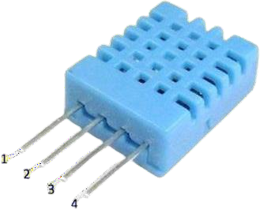

##### Fig. 3.6 DHT11

* + - * Temperature range: 00 - 500 C
      * Humidity Range: 20% - 90%
      * Operating Voltage: 3.5V to 5.5V
      * Operating current: 0.3mA (measuring) 60uA (standby)
      * Output: Serial data
      * Temperature Range: 0°C to 50°C
      * Humidity Range: 20% to 90%
      * Resolution: Temperature and Humidity both are 16-bit
      * Accuracy: ±1°C and ±1%

##### Rain Drop Sensor: -

The Raindrops Detection sensor module is used for rain detection. It is also for measuring rainfall intensity. Rain sensor can be used for all kinds of weather monitoring and translated into output signals and AO.

Raindrops Detection Sensor Module Rain Weather Module for Arduino, etc. Rain sensor can be used to monitor a variety of weather conditions and turned into several fixed output signal and Analog output.

It includes a printed circuit board (control board) that “collects” the raindrops. As raindrops are collected on the circuit board, they create paths of parallel resistance that are measured via the op-amp. The lower the resistance (or the more water), the lower the voltage output. Conversely, the less water, the greater the output voltage on the analog pin. A completely dry board, for example, will cause the module to output 5V.

The module includes a rain board and a control board that is separate for more convenience. It has a power indicator LED and an adjustable sensitivity through a potentiometer. The module is based on the LM393 op-amp.

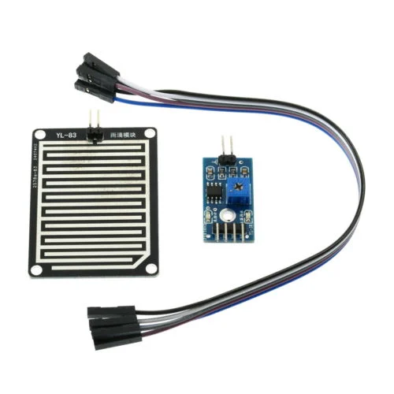

##### Fig. 3.7 Rain Drop Detection Sensor

**Features**:

The LM393, use of the wide voltage comparator

Provide both digital and analog output

Output LED indicator

TTL Compatible

The sensor uses the high-quality FR – 04 double material, the large area of 5.5 * 4.0 CM

Treatment of nickel plating and surface, have fight oxidation, electrical conductivity, and life has more superior performance

The comparator output, signal clean, good waveform, driving ability is strong, for more than 15 mA;

With potentiometer sensitivity adjustment

The output format: digital switch output (0 and 1) and analog AO voltage output;

Has a fixed bolt hole, convenient installation

It includes: -

1 x Printed Circuit Board for Rain Water Collection

1 x Control Board with LM393 Voltage Comparator

A 5-Wire Dupont Cable

Operating Voltage (VDC)

3.3 ~ 5

Voltage Comparator

LM393

Driver Size(mm)

32x15x9 (LxWxH)

Collector Board Size(mm)

54x40x1.5 (LxWxH)

##### Moisture Sensor: -

This is an easy-to-use digital soil moisture sensor. Just insert the sensor in the soil and it can can measure moisture or water level content in it. It gives a digital output of 5V when moisture level is high and 0V when the moisture level is low in the soil. The sensor includes a potentiometer to set the desired moisture threshold. When the sensor measures more moisture than the set threshold, the digital output goes high and an LED indicates the output. When the moisture in the soil is less thatn the set threshold, the output remains low. The digital output can be connected to a micro controller to sense the moisture level. This sensor is great for making water gardening projects, water sensing, etc.

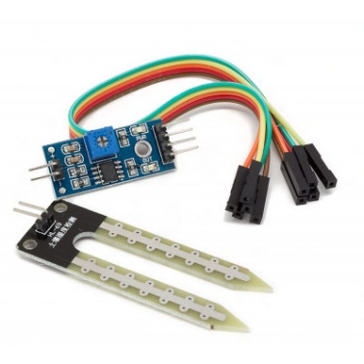

##### Fig 3.8 Soil Moisture Sensor

##### Specifications:-

##### Operating voltage: 3.3V~5V

##### Dual output mode, analog output more accurate

##### A fixed bolt hole for easy installation

##### With power indicator (red) and digital switching output indicator (green)

##### Having LM393 comparator chip, stable

##### Panel PCB Dimension: Approx.3cm x 1.5cm

##### Soil Probe Dimension: Approx. 6cm x 3cm

##### Cable Length: Approx.21cm

##### VCC: 3.3V-5V

##### GND: GND

##### DO: digital output interface (0 and 1)

##### AO: analog output interface

##### Connections: -

##### VCC connect to 3.3V-5V

##### GND connect to GND

##### DO digital value output connector（0 or 1）

##### AO analog value output connector

##### Usage: -Soil moisture module is most sensitive to the ambient, generally used to detect the moisture content of the soil.

##### When the module cannot reach the threshold value, DO port output high, when the the soil humidity exceeds a set threshold value, the module D0 output low;

##### The small board digital output D0 can be connected directly to the MCU, MCU to detect high and low, to detect soil moisture; Small board digital output DO can directly drive the buzzer module or relay module in our store, which can form a soil moisture alarm equipment; Small board analog output AO and AD module connected through the AD converter, you can get more precise values ​​of soil moisture.

##### Water valve

12V Solenoid Water Air Valve Switch (Normally Closed) – 1/2” controls the flow of fluid (liquid or air) and acts as a valve between high-pressure fluid! This liquid valve would make a great addition to your robotic gardening project. There are two ½” (Nominal NPT) outlets.

Normally, the valve is closed. When a 12V DC supply is applied to the two terminals, the valve opens and water can push through. The flow rate is ≥1.8L/min when the water pressure is 0.02MPa; the flow rate is ≥20L/min when the water pressure is 0.8MPa. The valve works with the solenoid coil which operates electronically with DC 12-volt supply. As it is a normally closed assembly, it opens the flow of fluids as soon as it is powered ON and stops/blocks the flow when the supply voltage removed.

While Connecting Valve in Flow pipeline, you need to mind the Input and Output direction of the valve. It will work only if you connect it in the right direction.

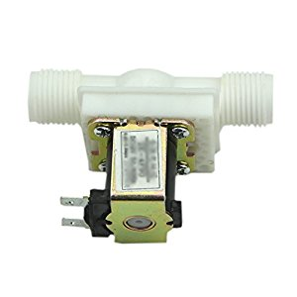

##### Fig 3.9 12V Solenoid Water Valve

##### Features:

##### Compact and convenient.

##### Easily installed and serviced

##### Precise and reliable.

##### The installation direction can be arbitrary Angle

##### Pressure-regulating valve (steady flow valve) function similar to the water flow switch

##### Not only can it provide a steady flow, but it also prevents the dry burning.

##### Suitable for fluids like water, oil, air.

##### seजल (Mobile Application)

seजल is a developed mobile application for analyzing the output.

With the inputs are carried to the platform it will process the data to mobile application where the decisions can be taken accordingly.

##### Design Tool

**Proteus (Circuit & layout design)**

The Proteus Design Suite is a proprietary software tool suite used primarily for electronic design automation. The software is used mainly by electronic design engineers and technicians to create schematics and electronic prints for manufacturing printed circuit boards. It was developed in [Yorkshire](https://en.wikipedia.org/wiki/Yorkshire), England by Lab center Electronics Ltd and is available in English, French, Spanish and Chinese languages.

The Proteus Design Suite is a Windows application for [schematic capture](https://en.wikipedia.org/wiki/Schematic_capture), [simulation](https://en.wikipedia.org/wiki/Computer_simulation), and PCB ([Printed Circuit Board](https://en.wikipedia.org/wiki/Printed_Circuit_Board)) layout design. It can be purchased in many configurations, depending on the size of designs being produced and the requirements for microcontroller simulation. All PCB Design products include an auto router and basic mixed mode SPICE simulation capabilities.

In the initial stage the virtual prototype was designed on the Proteus platform. As the sensors specified in the hardware specification, virtual connections are carried out. The whole process was performed and analyzed to the output.

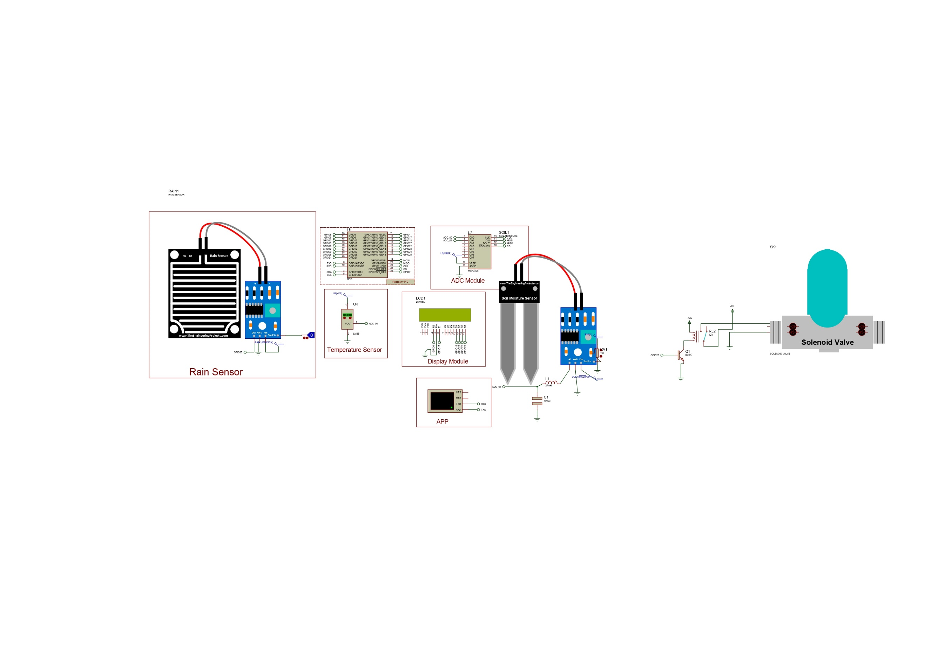

##### Fig. 3.9 Proteus Simulation

**CHAPTER 4**

##### SYSTEM IMPLEMENTATION

* 1. **Implementation**

Our project delivers a neat analysis of temperature, humidity, and moisture for the agriculture sector. This process includes various stages from simulation to product decision. At the initial stage, the prototype was supposed to work for processing the Min & Max temperature of day which was further transformed to be used for precision agriculture. There were many experiments with the components, Software and hardware entities performed during the process. The implementation is carried out is various stages.

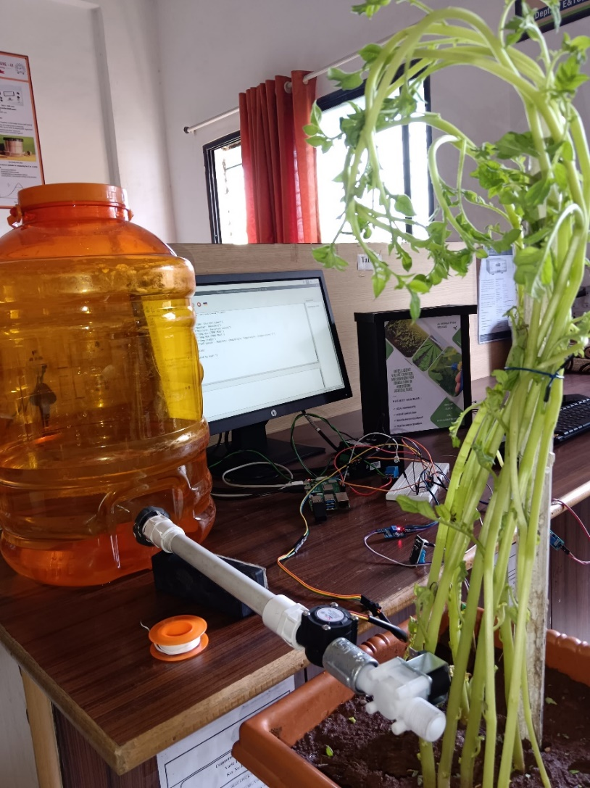

##### Fig. 4.1 Hardware Design

Soil moisture sensor when installed in execution works and records the data from the surrounding. It is in the form of analog signal. Humidity or moisture is the parameter which is analyzed by the sensor. After collecting the data, the same is transmitted to Analog to Digital converter (ADC) which converts the recorded analog signal to digital signal.

Coordinately DHT11 sensor particularly measuring the Temperature parameter in this process. These digital signal from the DHT11 and soil moisture sensor is transmitted to Raspberry pi 4b. After receiving the data Raspberry pi 4b with principle of wireless communication pushes the data to the data storage.

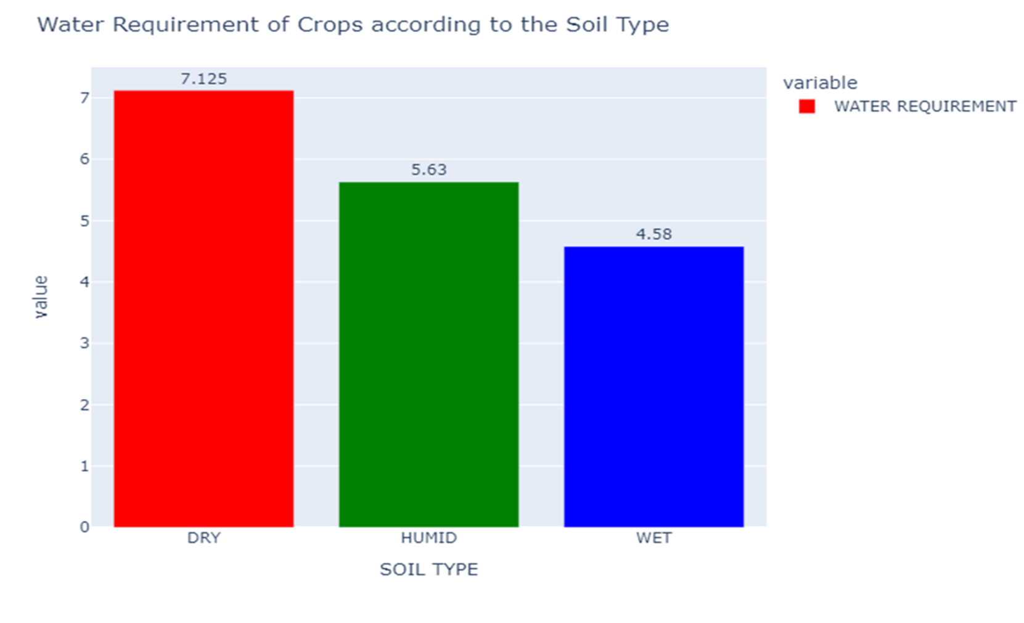

##### Fig. 4.2.1 Data Visualization

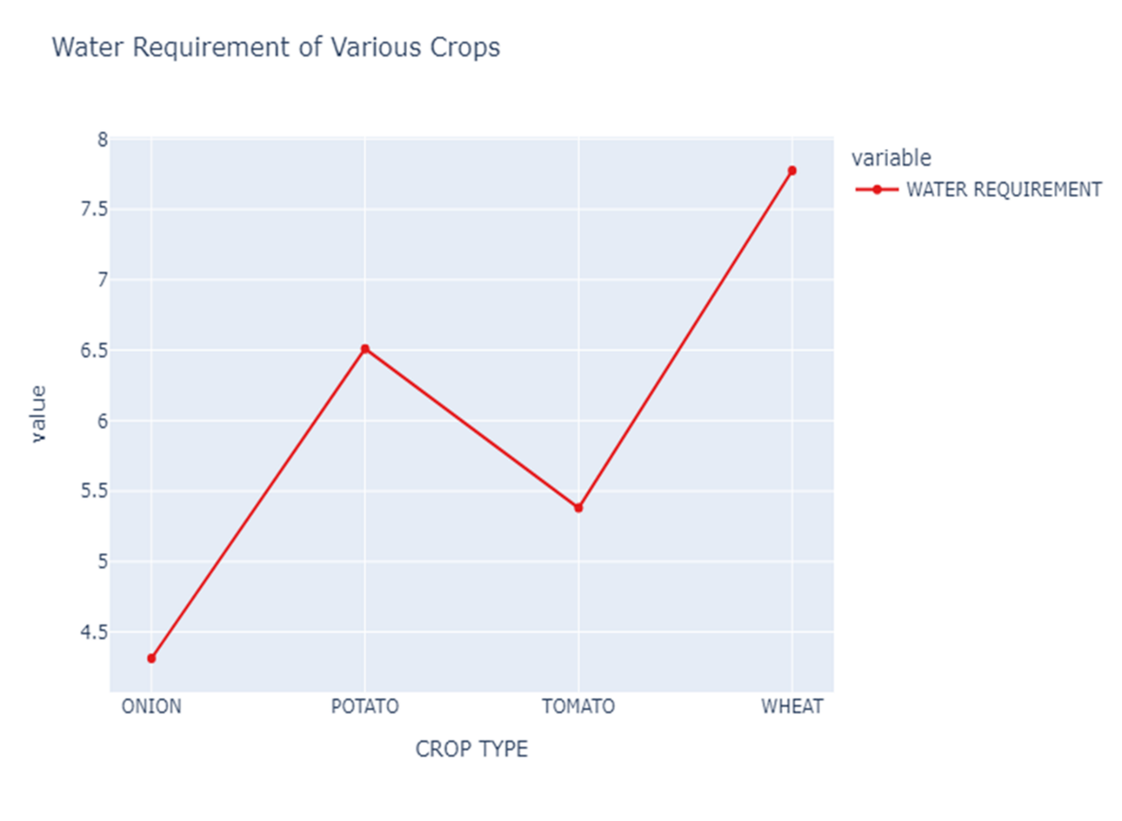

**Fig 4.2.2 Data Visualization**

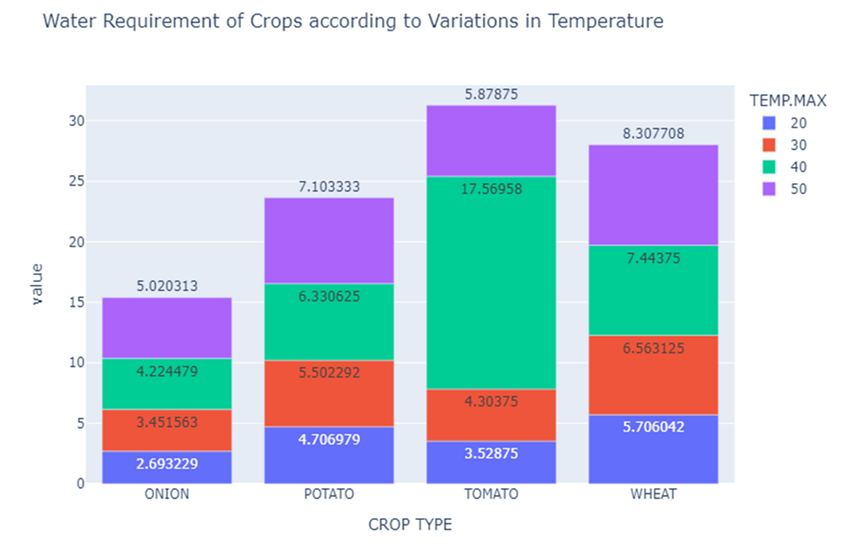

**Fig 4.2.3 Data Visualization**

It is a modern and widely used platform to aggregate, visualize, and analyze live data streams in the cloud. After various processes, a graphical representation of the data is plotted and a comma-separated values (.csv) file is generated. This data is manually transmitted to mobile application and can be monitored as an output. **seजल** is a mobile application developed for this project.

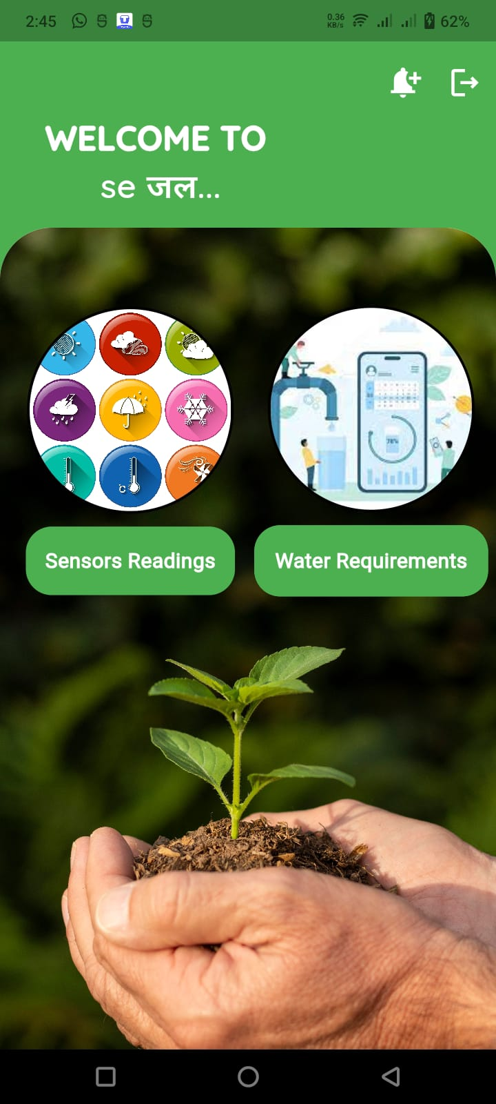

##### Fig. 4.3 seजल Welcome Page

This is the welcome page of the developed mobile application “**seजल**”, where we can monitor and control output parameters.

##### Random Forest Algorithm

Random forest is a bagging method with just a small tweak and that is it decides where to split based on a random selection of features.

max_features parameter

Learning is quite sensitive to max_features. Setting max_features = 1, leads to forests with more diverse, more complex trees. Setting max_features = #features, will lead to similar forests with similar trees.

Prediction Using Random Forests Make predictions for every tree in the forest. Combine individual predictions (probabilities averages across trees, predict the class with highest probability).

**Advantages:**

Widely used, excellent prediction performance on many problems

Does not require feature normalization like other linear models

Like Decision tree, handles a mixture of feature types.

Easily paralyzed across multiple CPUs.

**Disadvantages:**

Resulting models are usually difficult for humans to interpret.

Like Decision tree, random forest are not good choice for very high dimensional tasks (like text data) compared to fast, more accurate linear models.

**Key parameters:**

n_estimators: number of trees to use in ensemble (default: 10). It should be larger for larger datasets to reduce overfitting (but uses more computational).

max_features: has a strong effect on performance. Influences the diversity of trees in the forest.

max_depth: controls the depth of each tree (default: None, splits until all leaves are pure).

n_jobs: how many cores to use in parallel during training.

##### CHAPTER 5

##### RESULTS

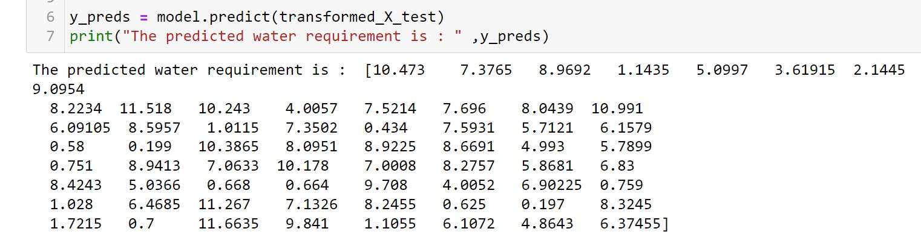

##### Fig. 5.1 Testing Water Prediction

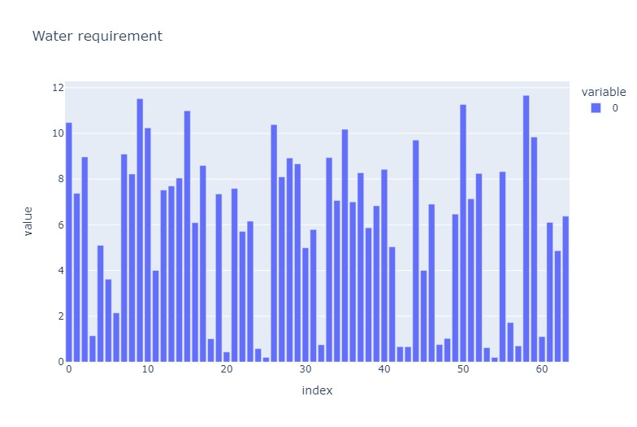

**Fig. 5.2 Plot of water requirement**

##### seजल Mobile Application Interface

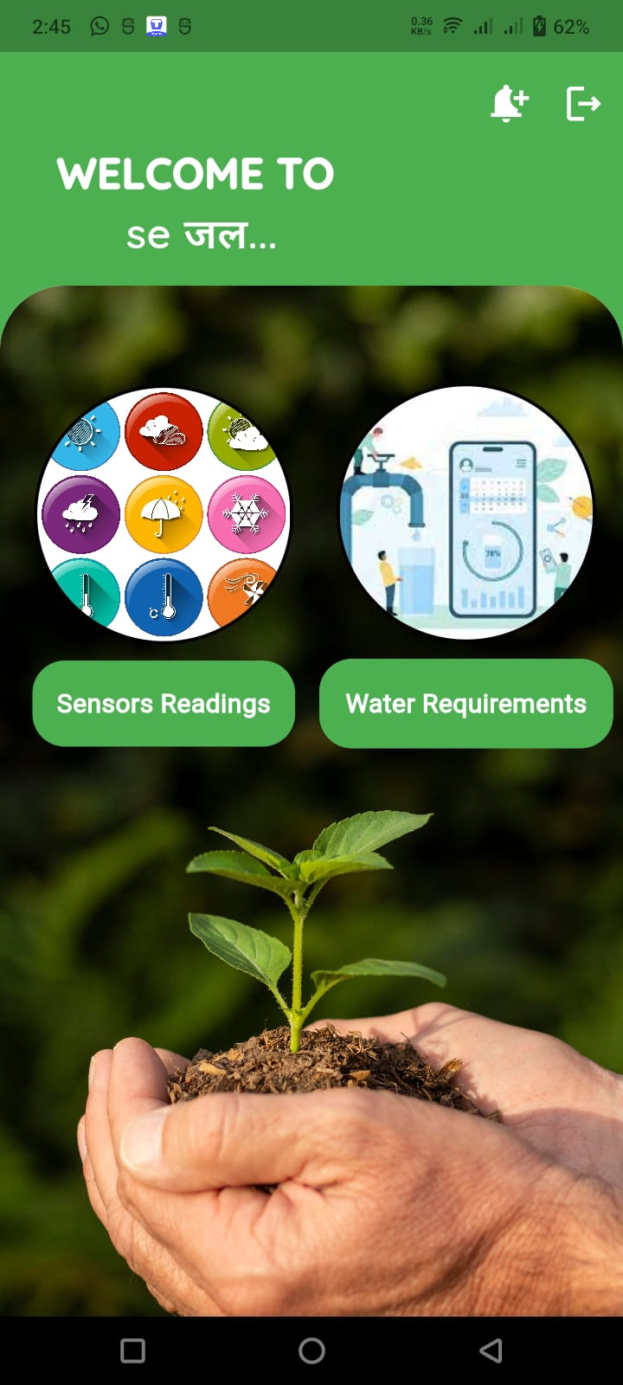

**Fig. 5.3 seजल Home Page Fig .5.4 Login Page**

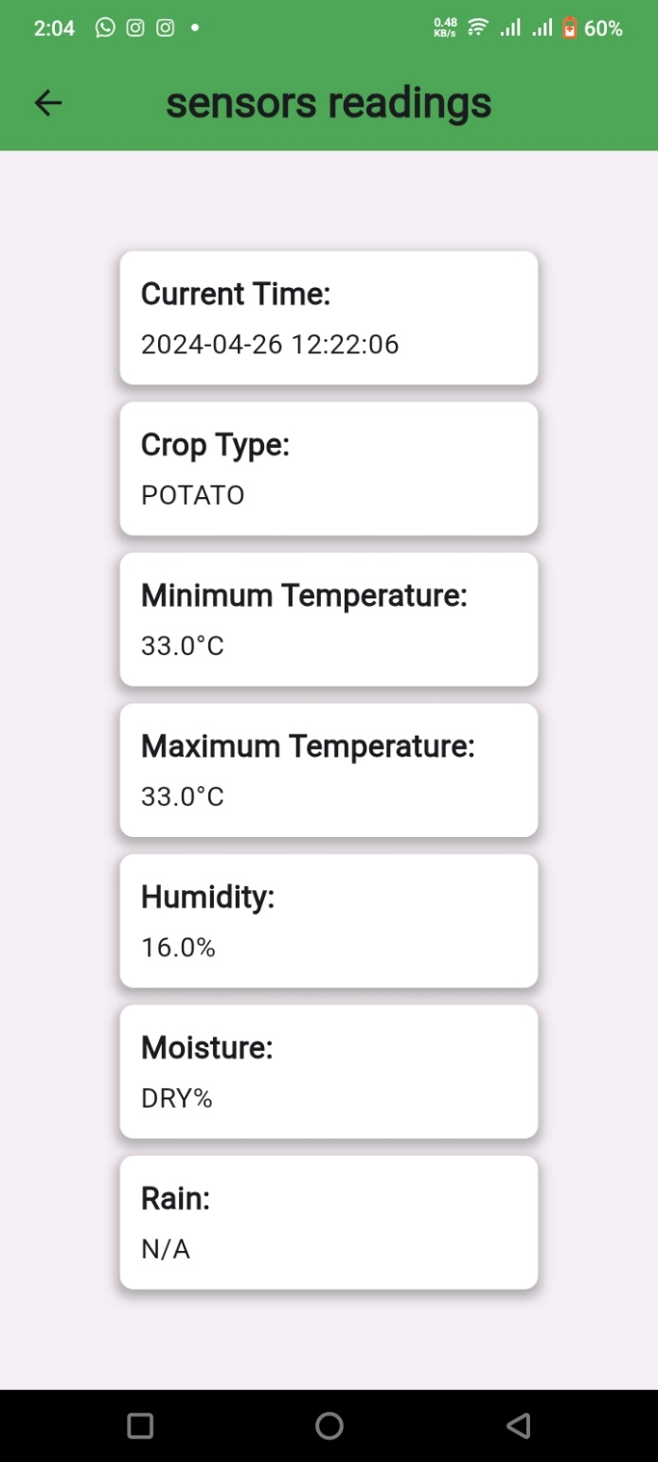

##### Fig. 5.5 seजल Sensor Record Page

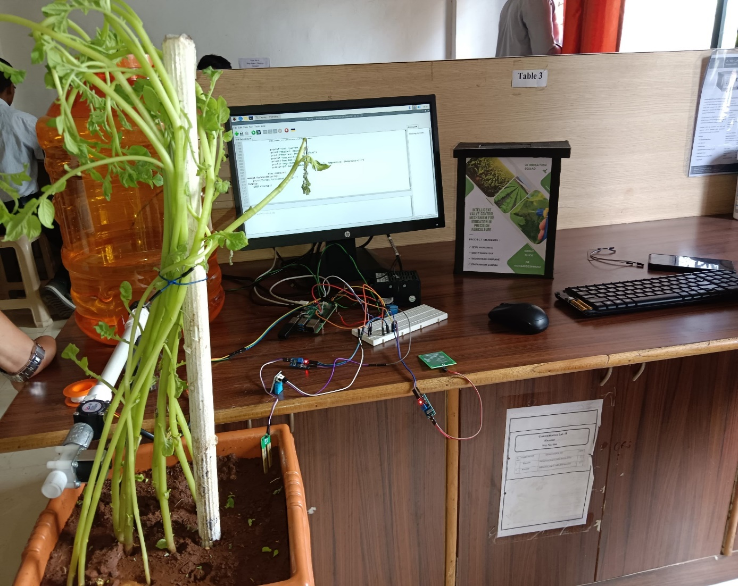

**Fig. 5.5 System Implementation**

**CHAPTER 6**

##### ADVANTAGES, LIMITATIONS, APPLICATIONS & FUTURE SCOPE

* 1. **Advantages**

##### Maximized Crop Yields: This innovative system ensures that crops receive the precise amount of water they need at the right time. This optimization leads to consistently increased crop yields, promoting higher agricultural productivity.

##### Efficient Water Management: By preventing overwatering and only delivering water when necessary, the system significantly reduces water consumption. This efficient water management is critical in regions facing water scarcity and enhances the sustainability of farming practices.

##### Environmental Stewardship: The system contributes to environmental protection by curbing water pollution through targeted irrigation practices and conserving groundwater resources. It aligns with sustainable agriculture principles by reducing the environmental impact of farming activities.

##### Enhanced Crop Quality: The system's precision in water delivery leads to crops of consistently higher quality. Improved crop quality can result in better market prices, increased customer satisfaction, and enhanced competitiveness in the agricultural sector.

##### Data-Driven Decision-Making: The integration of AI and machine learning enables data-driven decision-making, optimizing irrigation schedules and resource utilization. This leads to more informed and strategic choices in agricultural management.

##### Limitations

* + - The data used to train the model is very less due to unavailability.

##### Applications

##### Agricultural Sector Implementation: The primary application is in the agricultural sector, where the intelligent valve control mechanism can be implemented on farms of various sizes, ranging from small-scale family farms to large commercial operations.

##### Smart Farming: The project can be a part of the broader concept of smart farming, where advanced technologies are utilized to optimize agricultural practices, increase productivity, and reduce resource wastage.

##### Crop Diversification: The system can be adapted for a diverse range of crops, including row crops (corn, soybeans, cotton), horticultural crops (fruits and vegetables), and specialty crops (such as vineyards and orchards).

##### Environmental Conservation: The system can also be employed in conservation efforts, such as wetland restoration projects or reforestation initiatives, where precise water control is essential for ecosystem health.

##### Urban Agriculture: In urban and peri-urban agriculture, where space is limited, the system can be applied to maximize crop yields in confined spaces, such as vertical farms and rooftop gardens.

##### Future Scope

* Enhanced Sensor Technologies: Advancements in sensor technologies, such as improved soil moisture sensors and remote sensing technology, can contribute to even more precise data collection, allowing for finer-tuned irrigation control.
* Machine Learning and AI Improvements: Further research in machine learning and artificial intelligence can lead to more sophisticated algorithms for predicting irrigation needs, optimizing water usage, and adapting to changing weather patterns.
* Climate Resilience: As climate change continues to impact global weather patterns, there is a need to develop systems that can adapt to more unpredictable and extreme conditions. Future research can focus on building resilience into irrigation control mechanisms.
* Energy-Efficient Solutions: Energy-efficient components and the integration of renewable energy sources can be explored to reduce the energy consumption of intelligent valve control systems, making them more sustainable.
* Mobile Applications and Remote Control: The development of user-friendly mobile applications and interfaces for remote control and monitoring can provide farmers with greater accessibility and convenience in managing their irrigation systems.
* Data Analytics and Predictive Maintenance: The use of data analytics can help in the predictive maintenance of irrigation equipment, reducing downtime and ensuring the system's reliability.
* Water Quality Monitoring: Expanding the system to include water quality monitoring can help ensure that the water being used for irrigation is of the highest quality, preventing soil contamination.

##### CHAPTER 7 CONCLUSION

In conclusion, the "Intelligent Valve Control Mechanism for Irrigation in Precision Agriculture" project represents a significant advancement in the field of agriculture through the integration of IoT and machine learning technologies. The project's main objective was to develop a system that could effectively manage irrigation in agricultural fields to maximize crop yield while minimizing water wastage. By combining hardware components such as moisture sensors, humidity sensors, rain sensors, and a flow sensor with a sophisticated machine learning model, the project has successfully achieved its goal.

One of the key features of the project is its ability to accurately predict the water requirements of crops based on various environmental factors. The machine learning model, trained on data related to soil moisture, weather humidity, and rainfall, can make precise predictions about the amount of water needed for irrigation. This capability is crucial in ensuring that crops receive the right amount of water at the right time, thus avoiding under-watering or over-watering, which can significantly impact crop yield.

Another important aspect of the project is its automation capabilities. The intelligent valve control mechanism, controlled by the machine learning model, can automatically start and stop the flow of water from the water tank based on the predicted water requirements. This automation not only reduces the need for manual intervention but also ensures that irrigation is done efficiently and effectively.

Moreover, the project's use of IoT technology allows for real-time monitoring and control of the irrigation system. Farmers can remotely access the system and monitor the status of the irrigation process, receive alerts in case of any anomalies, and adjust the settings as needed. This level of control and monitoring can help farmers optimize their irrigation practices and improve crop yield.

Overall, the "Intelligent Valve Control Mechanism for Irrigation in Precision Agriculture" project has demonstrated the potential of IoT and machine learning in revolutionizing agricultural practices. By providing an efficient and automated irrigation solution, the project has the potential to significantly improve crop yield, reduce water wastage, and contribute to sustainable agriculture.

##### PROJECT TIMELINE

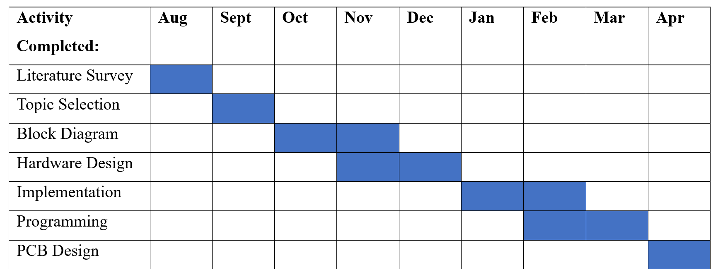

**REFERENCES**

1. *Al-Fuqahaa, A., et al. (2017). "Developing a Smart Irrigation System Using Arduino." Computers and Electronics in Agriculture, Vol. 143, pp. 179-190. [This paper details an Arduino-based smart irrigation system using soil moisture sensors]*
2. *Jayaraman, K., et al. (2018). "Review on Precision Agriculture with Internet of Things." Agricultural Reviews, Vol. 37(1), pp. 43-52. [This review paper discusses the role of IoT in precision agriculture]*
3. *Aditya Patil (2023). "Soil Moisture Sensor Interfacing with Arduino Uno.* [*https://www.youtube.com/watch?v=ja3ieY4UHEc*](https://www.youtube.com/watch?v=ja3ieY4UHEc) *(This YouTube video demonstrates interfacing a soil moisture sensor with Arduino)*
4. *Lu, R., et al. (2016). "Wireless Sensor Network for Monitoring Soil Moisture and Temperature." Sensors (Switzerland), Vol. 16(2), p. 179. [This paper discusses a wireless sensor network for monitoring soil moisture and temperature]*
5. *Mao, D., et al. (2019). "Design of a Smart Irrigation System Based on Machine Learning." IEEE Access, Vol. 7, pp. 142407-142417. [This paper describes a smart irrigation system design using machine learning]*
6. *Singh, R., et al. (2020). "Machine Learning for Precision Irrigation in Agriculture: A Review." Journal of the Indian Society of Agricultural Engineers, Vol. 13(2), pp. 189-202. [This review paper discusses the use of machine learning for precision irrigation]*